Food Management System

Use-Case-Realization Specification: Cancel Order

Version <1.0>

Revision History

|  |  |  |  |
| --- | --- | --- | --- |
| **Date** | **Version** | **Description** | **Author** |
| <24/12/2020> | <1.1> | Final Draft | Nguyen Thi Ngoc Anh |

Table of Contents

1. Introduction 2

1.1 Purpose 2

1.2 Scope 2

1.3 Definitions, Acronyms, and Abbreviations 2

1.4 References 2

1.5 Overview 2

2. Flow of Events—Design 2

3. Derived Requirements 2

Use-Case-Realization Specification: <Use-Case Name>

# Introduction

## Purpose

This document describes how the Cancel Order Use-Case is realized within the design model, in terms of collaborating objects.

## Scope

This document applies to the Food Management System which will be developed by our group – SAPAssDWill.

## Definitions, Acronyms, and Abbreviations

User – a person who use the system, can be customer or employee.

Admin – administrator

## References

None.

## Overview

In the following section, Use-Case Realization Specification of the Cancel Order Use-Case of the Food Management System is provided in detail. The first section is a textual description of the Use-Case specification. The following section contains diagrams (sequence and collaboration diagrams) describing how the use case is realized in terms of collaborating objects. The third section includes class diagrams with relationships that participate in the realization of the use case. The last section is an analysis of all requirements, such as non-functional requirements, on the use-case realization that are not considered in the design model, but that need to be taken care of during implementation.

# Flow of Events—Design

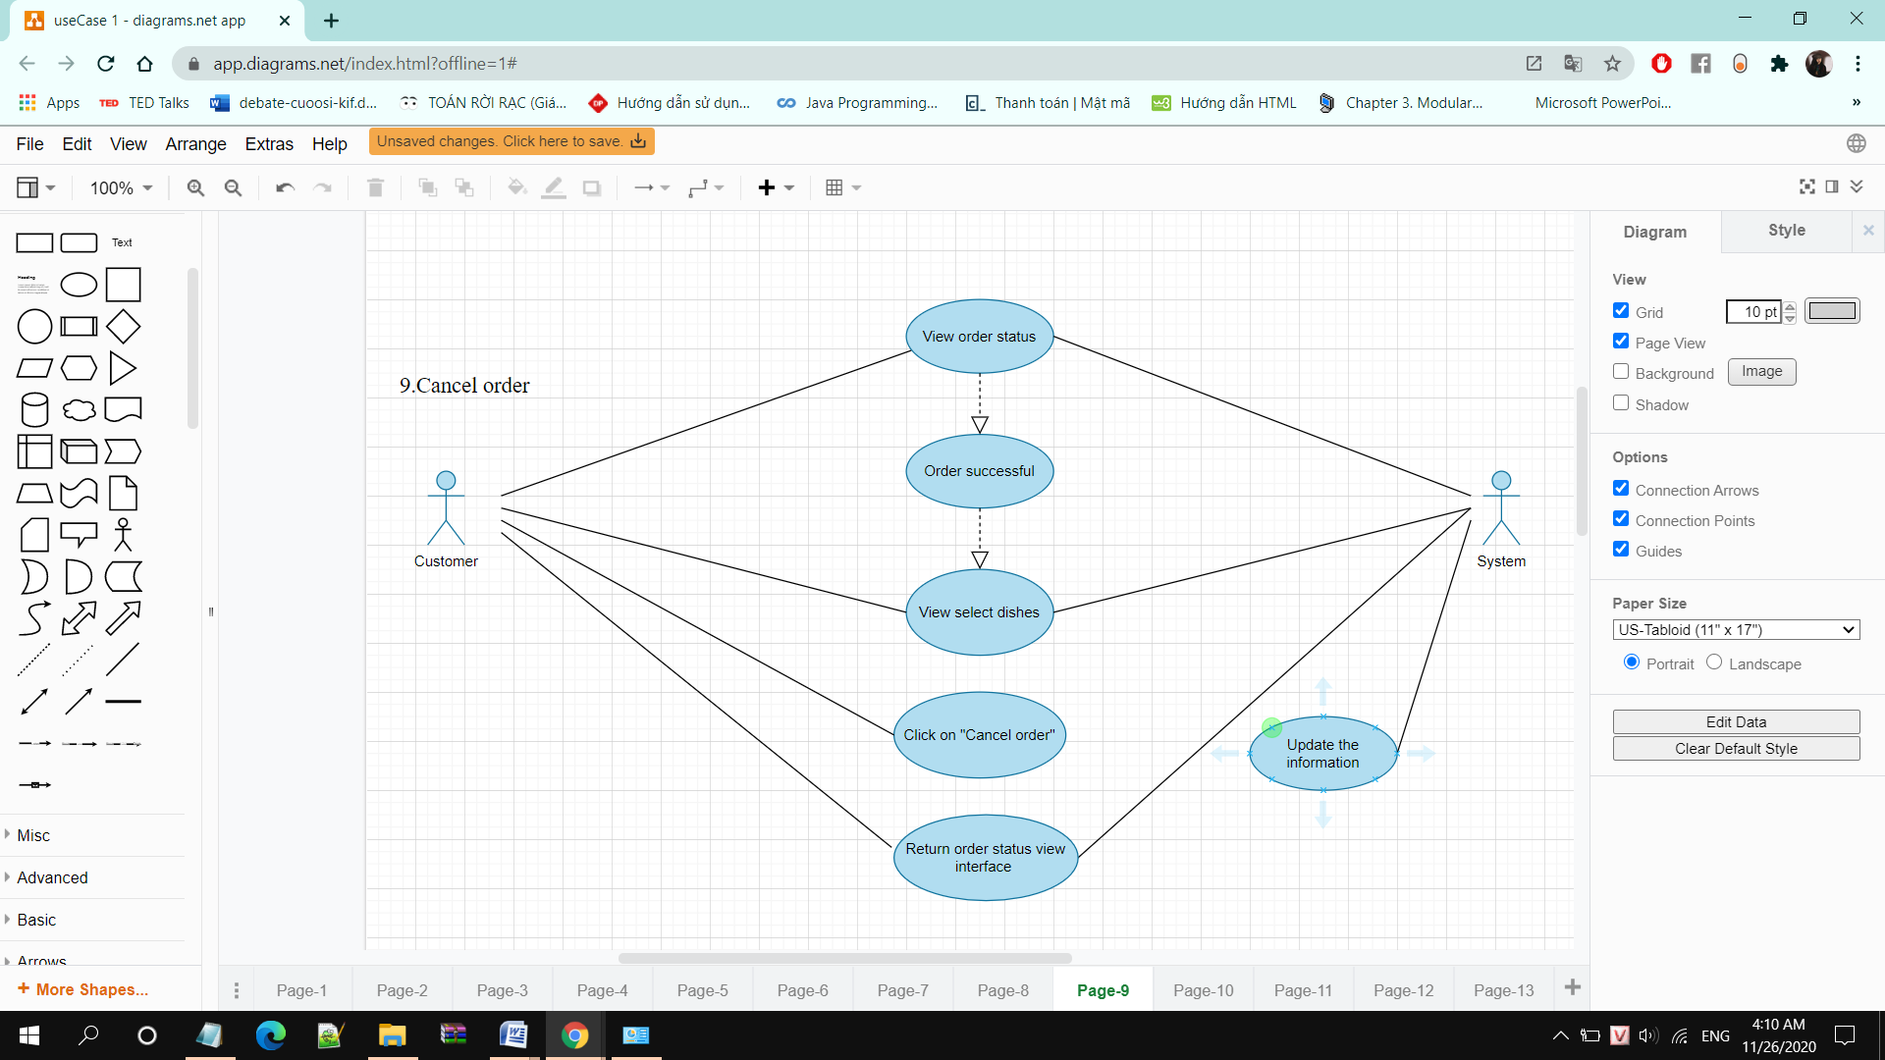

|  |  |
| --- | --- |
| Use case | Cancel orders |
| Actors | Customers, admin |
| Description | Customers cancel order that they have order |
| Trigger | Customers click “Cancel” on interface view selected dishes |
| Pre-conditions | Customers have ordered successfully and viewed order status |
| Post-conditions | Customers canceled order |
| Main Event Flow | 1. User clicks on “cancel order” on View order status interface  2. The system notifies the application cancellation confirmation  3. The user click”ok”  4. The system displays the user who has successfully canceled an order  5. The system returns to the order status view interface |

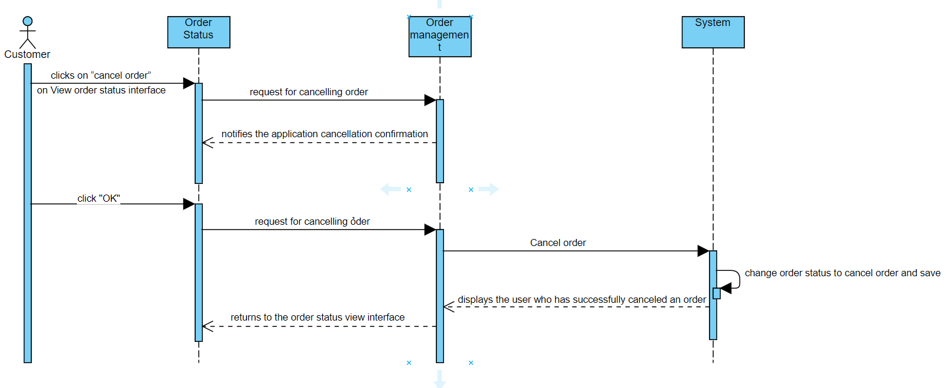

# Derived Requirements

None.